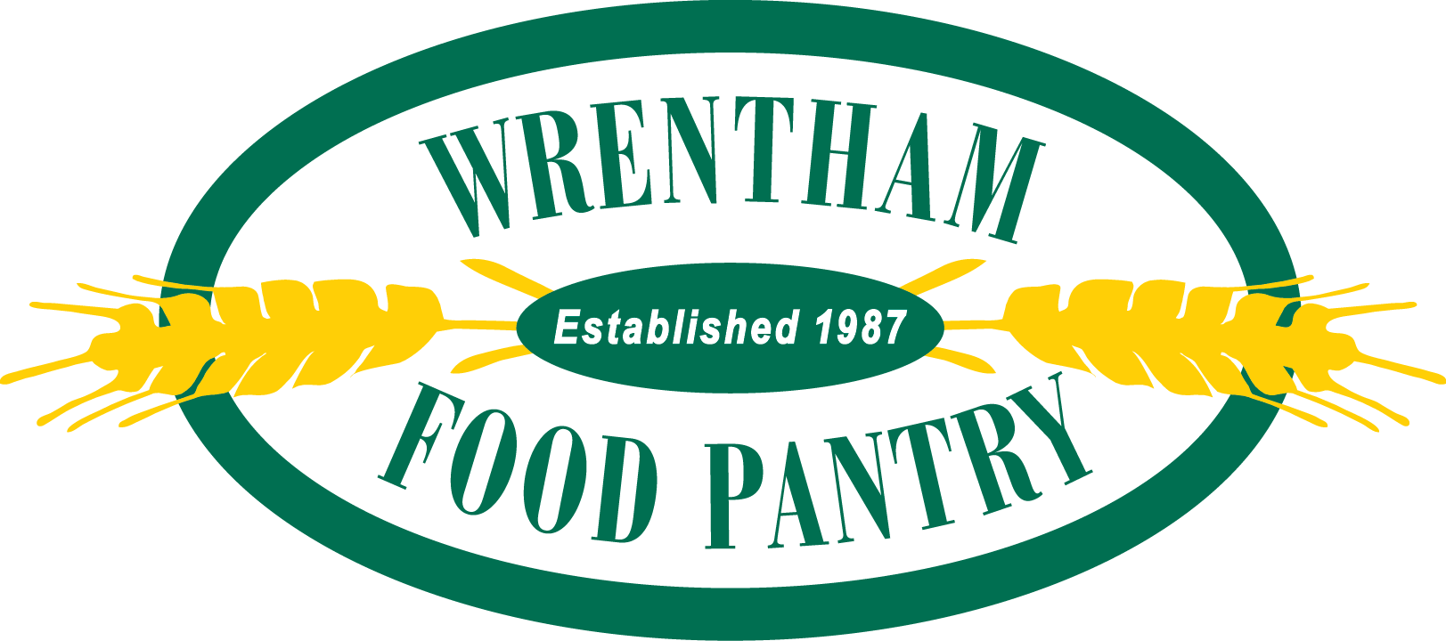

The Wrentham Food Pantry Thanks You for Your Support!

The WFP is a community pantry that supplies our neighbors in need with a 3-day supply of food. We are 100% volunteer-run so that 100% of monetary and non-perishable donations go directly to fill the shelves. Our doors are always open to any Wrentham resident in need, and with your help, we can continue to serve.

Neighbors Helping Neighbors

All unexpired, non-perishable items are welcome and appreciated!
Examples of items we provide weekly:

Strawberry or Grape Jelly/Jam
Peanut Butter -16-18 oz size
Tuna Fish – in water
Cold Cereal (10-14 oz size -please avoid large “family size” cereal boxes)
Quaker Oatmeal packages
Canned Fruit, Jarred Applesauce
“Tube” style pasta or Spaghetti
Jarred Pasta Sauce with Meat +/- 26 oz size
Rice – 1 - 2 lb. bags, or Near East brand pilaf
Diced Tomatoes
Mac and Cheese
Canned Vegetables
Baked Beans
Canned Beans – Black, Garbanzo, Kidney
Dry Milk
Toothpaste and Soap

